Part1:

Here we demostrate the output of a series of actions we did to ours system, in order to test the system’s functionality

Here is the initial content of order log(the first line shows the initial order serial number) and catalog file(there are two stocks, each has fives fields: name, price, current trade volume, current stock remaining, trade volume limit)

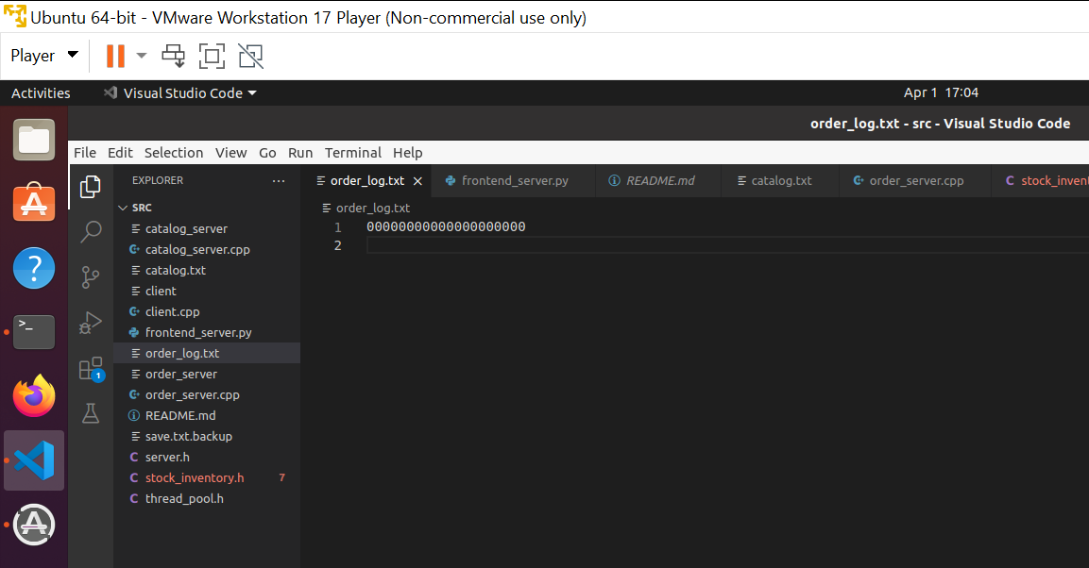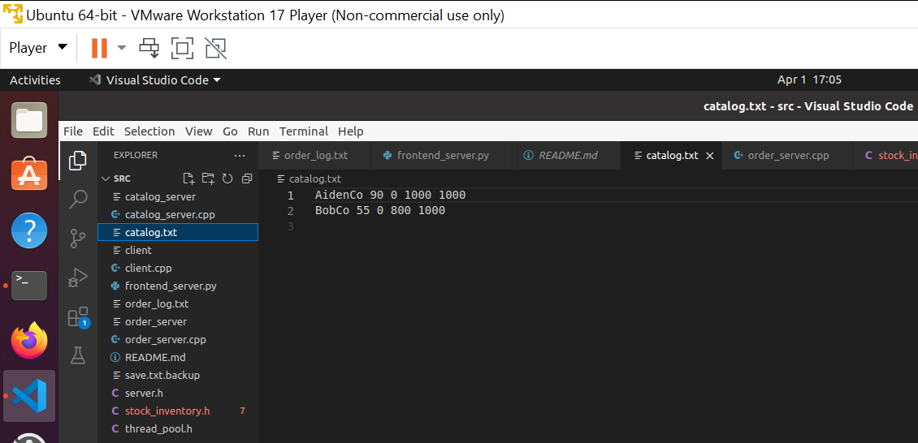

After we buy 10 stock from AidenCo, we check the info of AidenCo again. The result are within our expectation

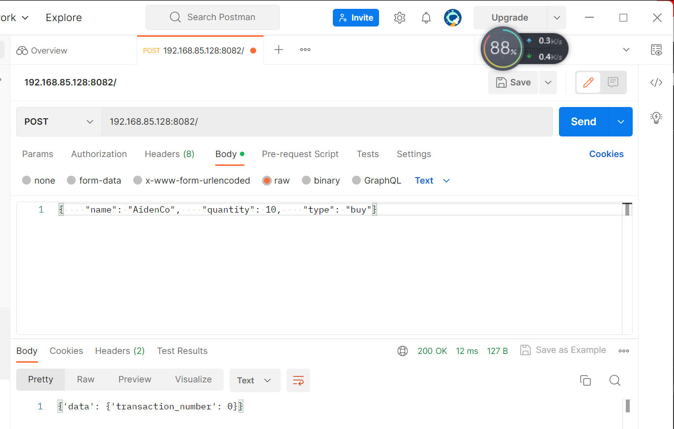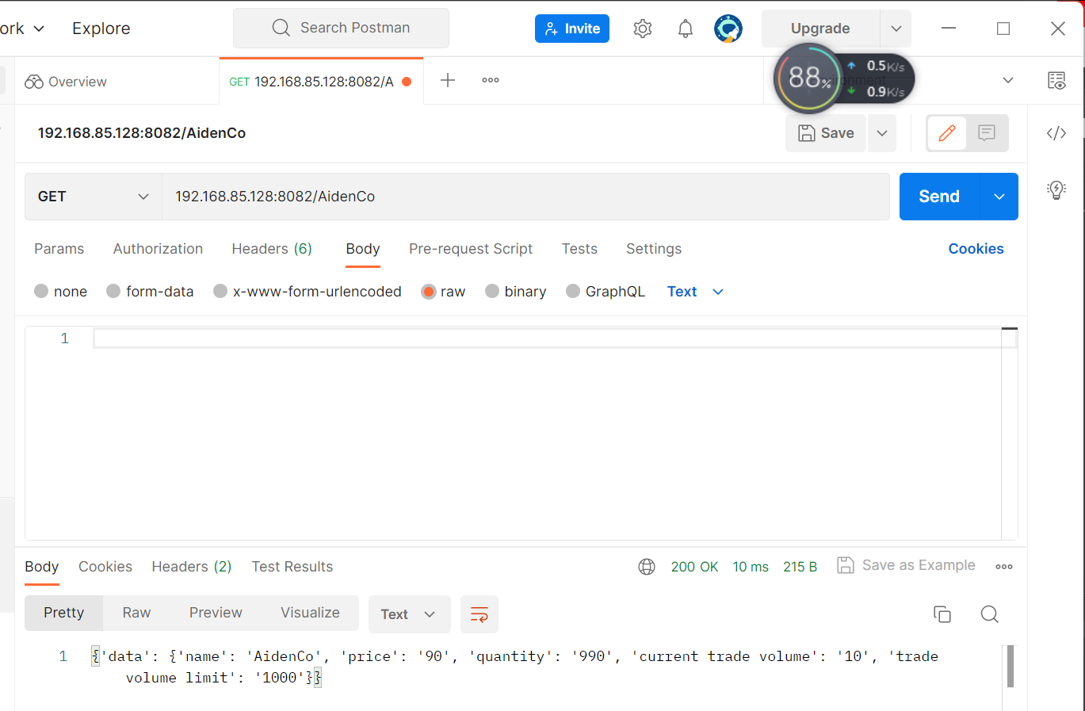

Then we try to buy 900 BobCo stocks, which exceeds the total stock remaining(the transaction failed, there will be no change to the stock category, and no transaction record will be generated)

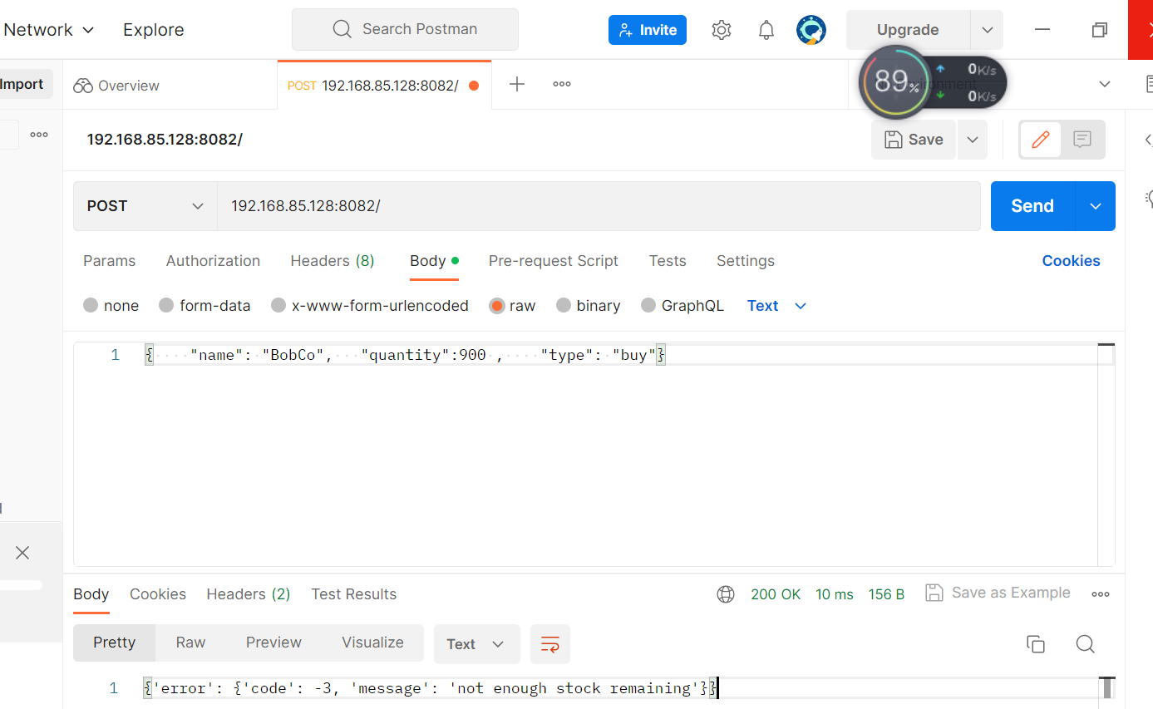

Part2:

here are some output from docker cmds, for more outputs please see the “comparison between docker and no-docker setting” in performance test part

Output of docker-compose

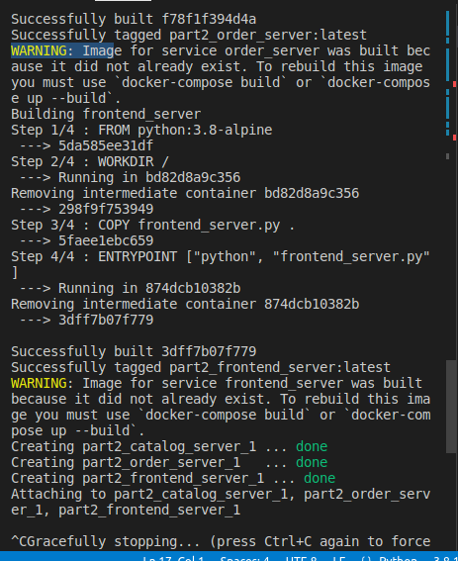

Output of docker ps

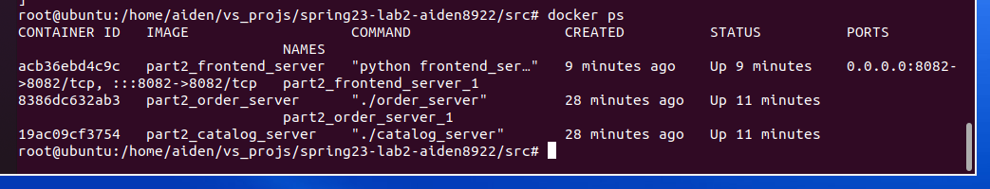

Then we sell 1000 AidenCo and check the info of AidenCo again.

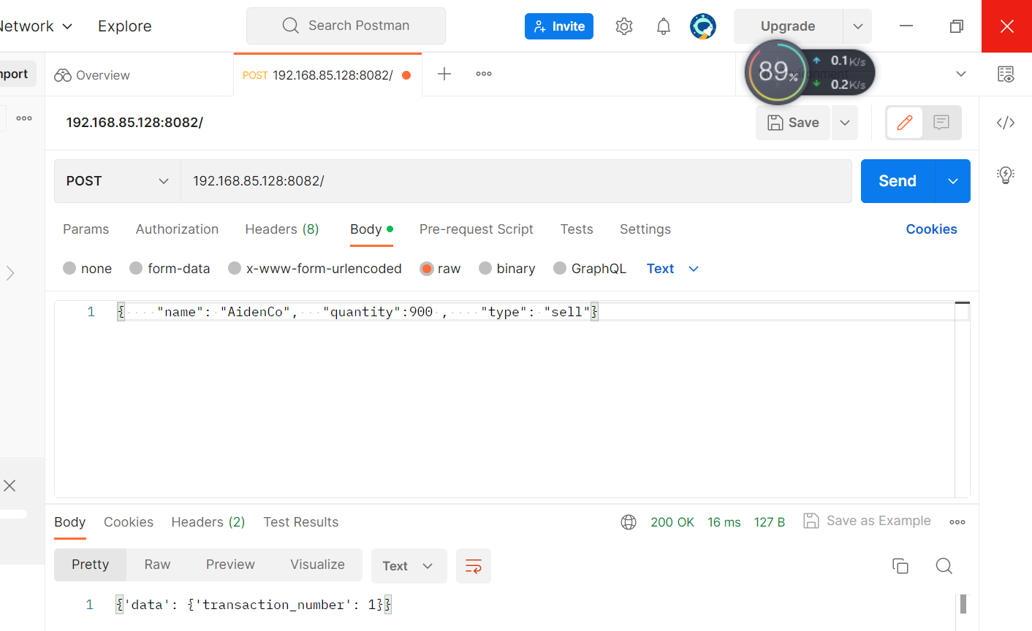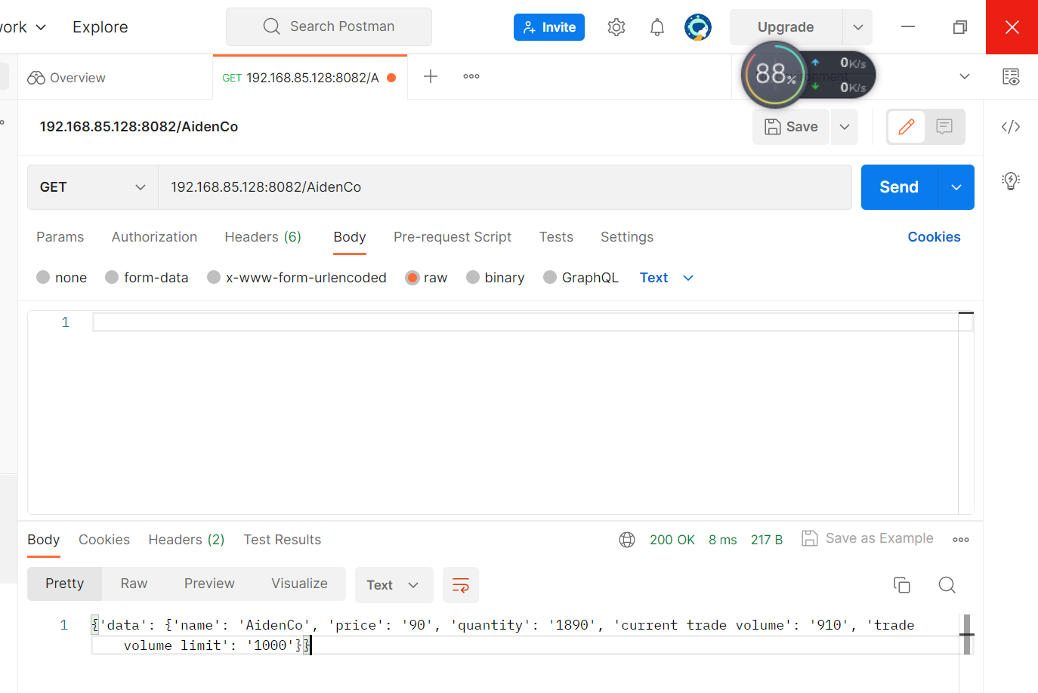

Notice that although there are many AidenCo stocks remaining, but the trade volume is very close to limit

Finally we try to buy 100 AidenCo stocks, which failed because the transaction would exceed trade volume limit

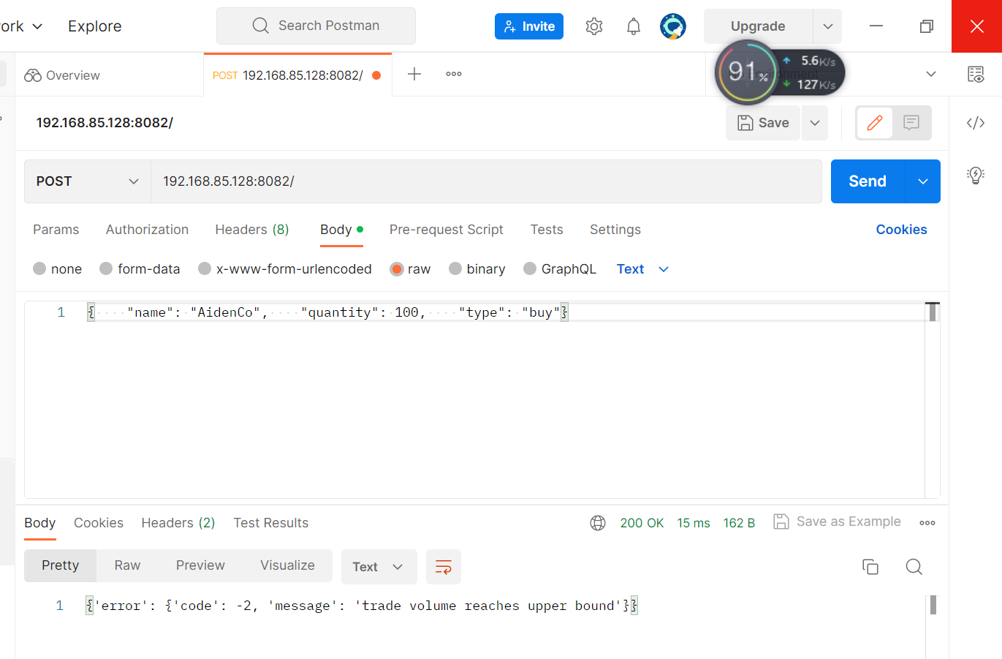

After we terminate the servers, the changes to the catalog and the transaction records will be written to the catalog file and order log

